**ASSISTED PRACTICE (FTP SAMPLER)**

Step1: Download filezilla Client

Step2: Give these FTP server details in filezilla :

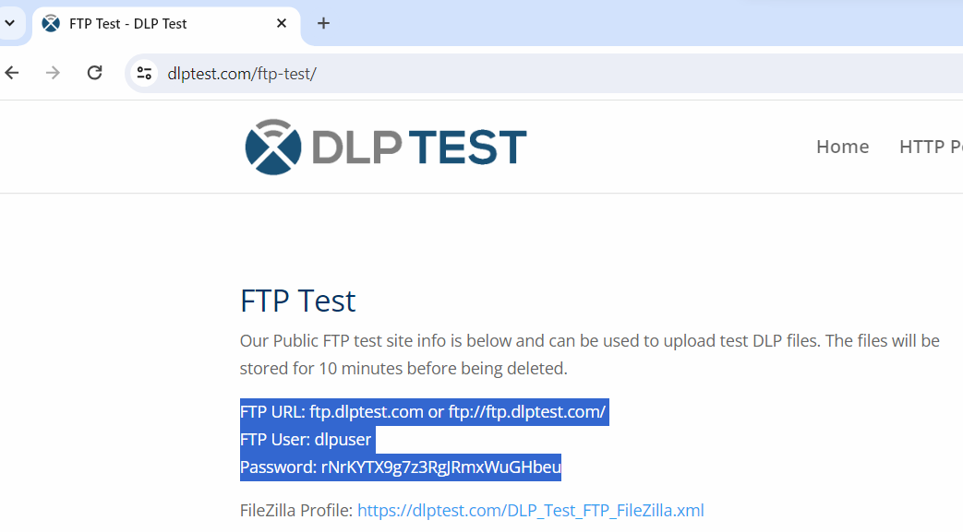

Step3: Create file in any folder on our machine

Step4: Now in filezilla we will find our file in the folder

Step5: Upload the file in remote directory(Right click on file and click on upload -> It will go to the remote directory in filezilla)

Step6: Now, remove that file from our server in filezilla (Check that file should also be deleted from our folder where we have saved that file in our machine)

Step7: Open Jmeter -> Add Thread Group

Step8: Right click on Thread Group -> Add -> Sampler -> FTP Request

Step9: In FTP request, Give the server name as same as we have given in filezilla, In remote file Give the path of our file as “/name of our file”, In Local File, Give the path of our folder where we have saved that file and Give the same username and password that we have given in filezilla

Step10: Right click on Thread Group -> Add -> Listener -> View results tree (to see the output) as shown below:

